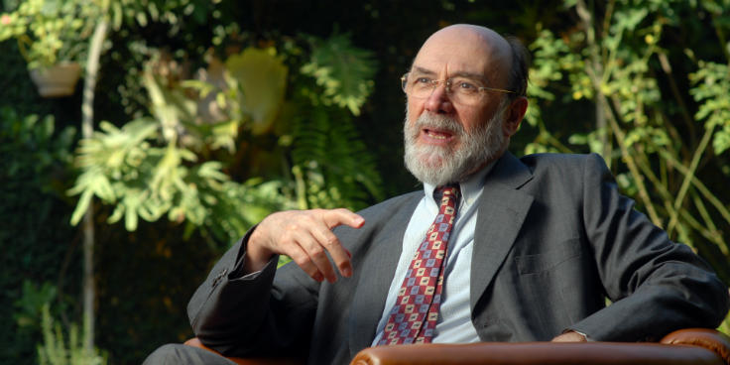
Professor Bolívar Lamounier taught at both the University of São Paulo and the Catholic University of São Paulo during the 70s and 80s. He was a member of the constitutional drafting commission, known as Comissão Afonso Arinos, appointed in 1985 by then President José Sarney. He was a member of the Social and Political Advisory Council (COPS) of the São Paulo Federation of Industries (FIESP) from 1989 to 2001, and chaired the Board of Directors of the Center for Public Opinion Research of the University of Campinas, São Paulo from 1993 to 2000. He was also a member of the consultative board of the Interamerican Dialogue, a Washington DC-based organization devoted to the study of US relations with Latin America. He was elected to the São Paulo Academy of Letters in 1997 and to the Brazilian Academy of Sciences in 2013. At present, Professor Lamounier is a member of the Academic Advisory Committee of the Club of Madrid, an organization created in 2001 by former presidents and prime ministers aiming to support democracy-building efforts on an international scale.
Dr. Lamounier is currently senior director of Augurium, a São Paulo-based consulting firm.
He earned his Ph.D in Political Science from UCLA - University of California at Los Angeles in 1974 and received his B.A. In Sociology from the University of Minas Gerais in 1964.

